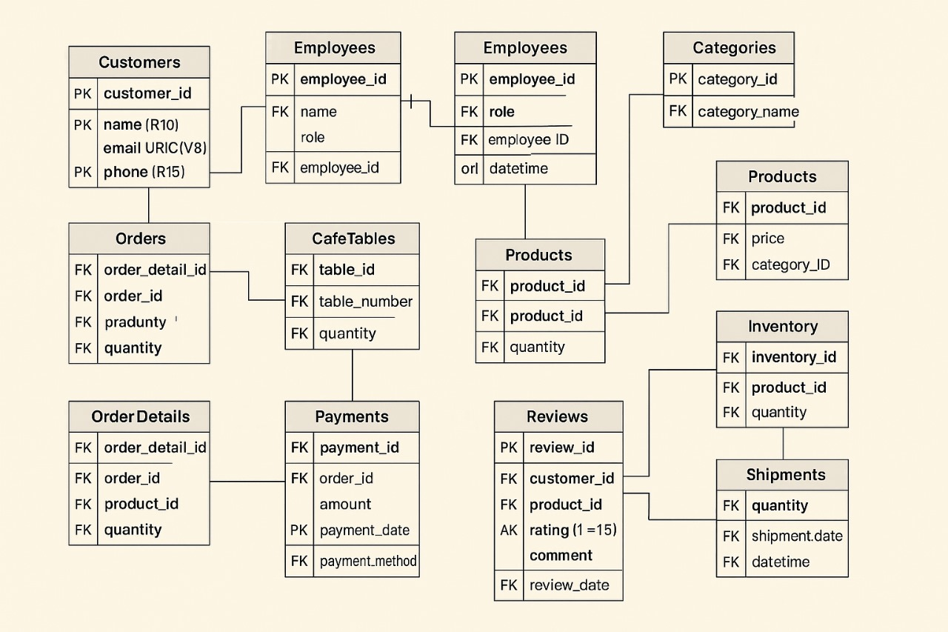Cafe Management System - Project Documentation

# Project Overview

This Cafe Management System is designed to streamline operations in a cafe by managing customers, orders, products, inventory, employees, and payments.   
The system handles essential tasks such as taking and tracking orders, processing payments, managing tables, reviewing product feedback, and keeping track of product inventory and shipments.  
It allows seamless communication between the cafe and its customers and helps in maintaining operational efficiency.

# Database Tables

* 1. Customers (customer_id, name, email, phone)
* 2. Employees (employee_id, name, role)
* 3. Orders (order_detail_id, order_id, product_id, quantity)
* 4. OrderDetails (order_detail_id, order_id, product_id, quantity)
* 5. Payments (payment_id, order_id, amount, payment_date, payment_method)
* 6. CafeTables (table_id, table_number, quantity)
* 7. Products (product_id, price, category_id, quantity)
* 8. Categories (category_id, category_name)
* 9. Inventory (inventory_id, product_id, quantity)
* 10. Shipments (quantity, shipment_date, datetime)
* 11. Reviews (review_id, customer_id, product_id, rating, comment, review_date)

# Database Normalization

The database has been normalized to the Third Normal Form (3NF) to reduce redundancy and ensure data integrity.  
  
1. First Normal Form (1NF):   
 - Each column contains atomic values.  
 - Each record is unique.  
  
2. Second Normal Form (2NF):   
 - All non-key attributes are fully functionally dependent on the primary key.  
 - Composite keys are removed by separating data into related tables.  
  
3. Third Normal Form (3NF):  
 - All columns are only dependent on the primary key.  
 - Transitive dependencies are removed (e.g., separating product category into a distinct Categories table).